Update Network Margin
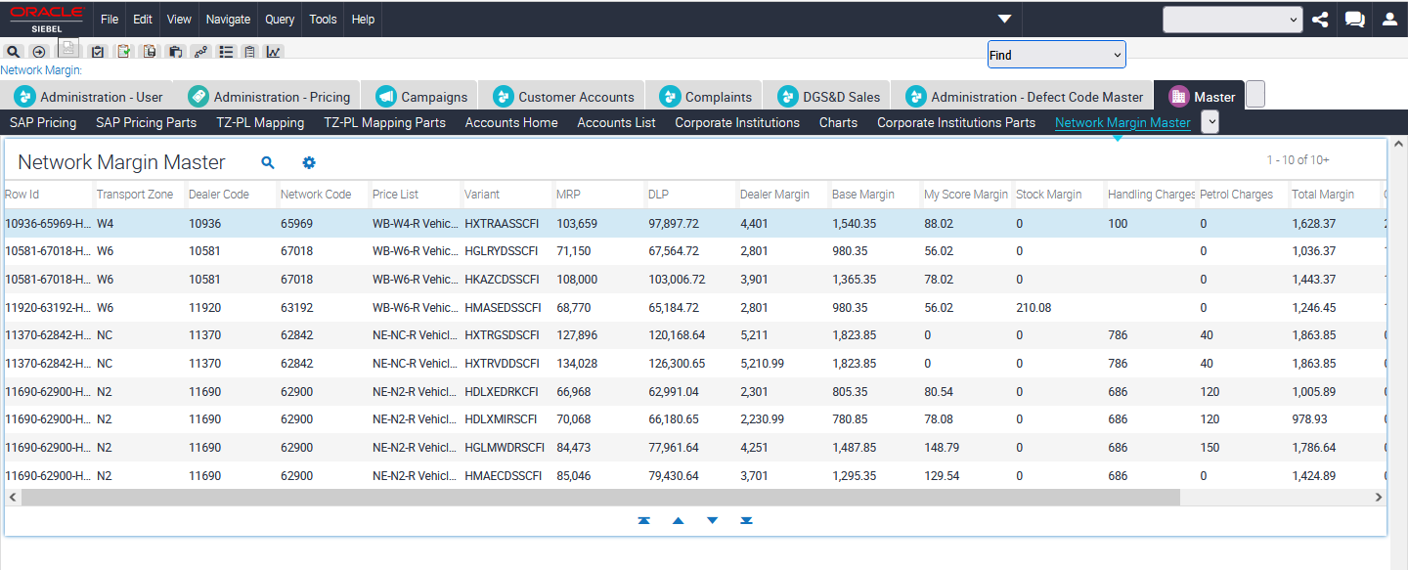
Step 1 – Transport Zone Check
1.1 - With the help of below mentioned SQL we can check that the Dealer is currently associated with any transport zone or not.
SQL Used –
SELECT
dlr.integration_id,dlr.x_cust_grp_sales TRANSPORT_ZONE
from
siebel.s_org_ext dlr
where
dlr.integration_id
in
('10221'); -- Put the dealer Code here to check the transport zone of dealer

On executing this SQL statement if we get null value for transport code, we need to update it with the help of below steps.
UPDATE siebel.s_org_ext
SET
x_cust_grp_sales = 'W1',
modification_num = modification_num + 1,
last_upd = sysdate - 5.5/24
WHERE integration_id in ('11659');
1.2 – Find Transport Zone with the help of Dealers Screen.
1.2.1 – Go to “Dealers” Screen All Dealers.
Query for given Dealer Code.
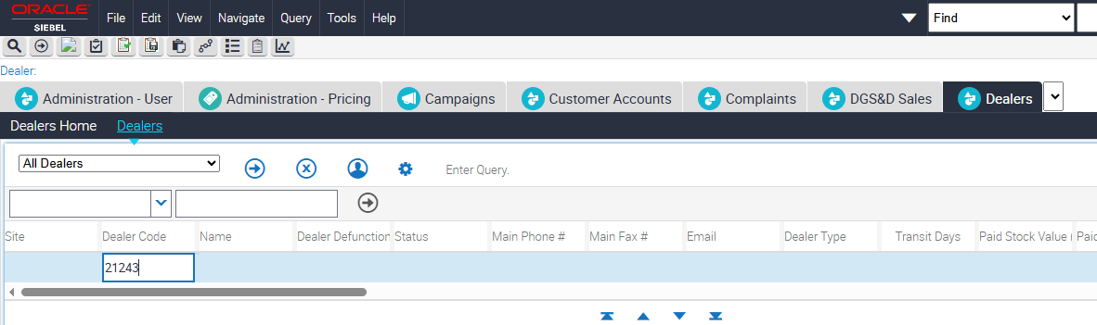

1.2.2 – Drilldown on Name Field Go to “Price List Detail View.
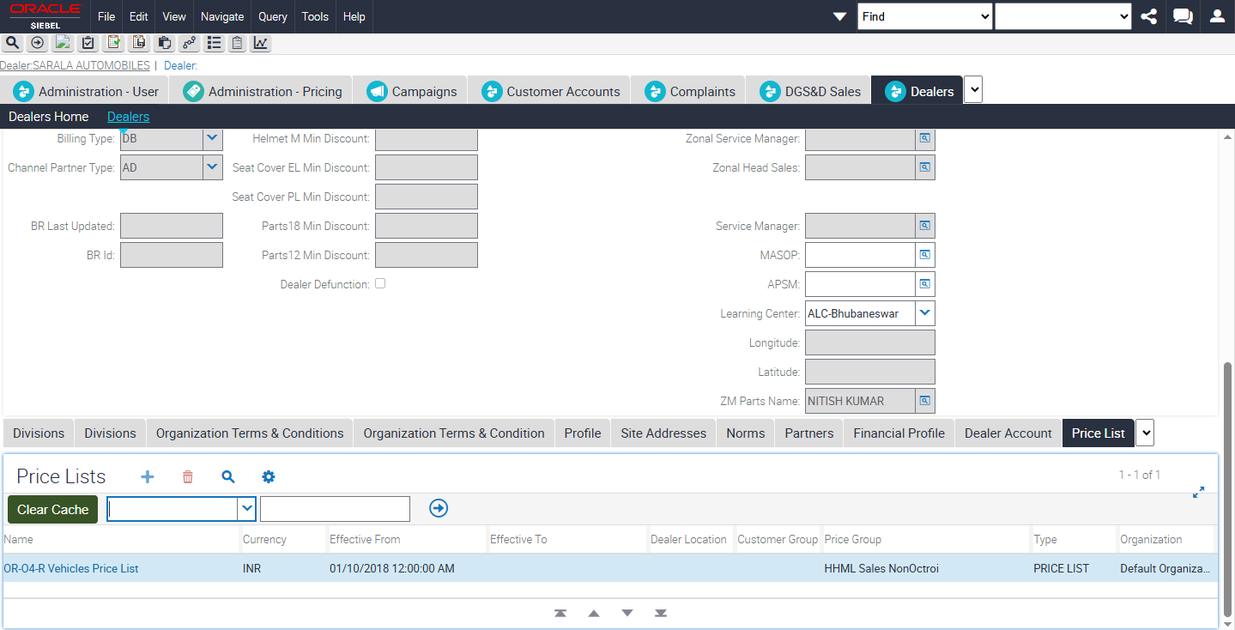

1.2.3 Query for “*R Vehicles Price List” in Name Field in Price Lists Applet.
Here we can see in above SS, upon querying “*R Vehicles Price List” we get value as -
OR-O4-R Vehicles Price List
Transport Zone - O4
1.3 – Updating the Transport Zone for Dealer Code
SQL Used -
update siebel.s_org_ext set x_cust_grp_sales = 'W4' where
integration_id in ('10235');
Step 2 – Network verification for Dealers.
SQL Used –
SELECT
distinct
ps.row_id,dlr.integration_id, ntw.integration_id
from
siebel.s_org_ext ntw
, siebel.s_org_ext dlr
, siebel.s_org_ext ps
, siebel.S_ORG_EXT_CSX glb
where
glb.GLOBAL_LOC_NUM = dlr.par_row_id
and glb.par_row_id = ntw.PAR_ROW_ID
and dlr.row_id = ps.integration_id(+)
and ntw.row_id = ps.x_account_dealer_code(+)
and dlr.integration_id
in ('11088')
and ntw.integration_id
in ('25135');
The network must be associated with the Dealer. Hence on executing above SQL there should be a record present with Dealer Code and Network.
Note – if not revert ticket with message. Network is not associated with Dealer. Please check.
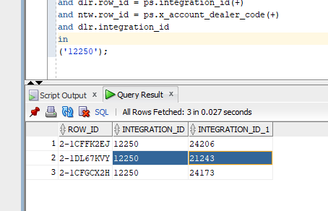

Step 3. – Update Paid Stock Margin flag to Y--- (Can be skipped)
This step is required for only for new dealers, or for a new network for the existing dealer.
SQL Used –
update siebel.s_org_ext set X_PAID_STOCK_MARGIN = 'Y'
where row_id in (SELECT
distinct
ps.row_id
from
siebel.s_org_ext ntw
, siebel.s_org_ext dlr
, siebel.s_org_ext ps
, siebel.S_ORG_EXT_CSX glb
where
glb.GLOBAL_LOC_NUM = dlr.par_row_id
and glb.par_row_id = ntw.PAR_ROW_ID
and dlr.row_id = ps.integration_id(+)
and ntw.row_id = ps.x_account_dealer_code(+)
--For new dealers
and dlr.integration_id
in ('11091','11296','12195')
--For New Networks
-and ntw.integration_id
--in ('64569'));

Step 4 – Verification for Network Margin Category Score --- (Can be skipped)
Verify that the Network Margin Category Score is available for all Networks associated with the Dealer.
SQL Used –
select * from siebelext.cx_ntw_margin_upl
where network_code in
('20956')
order by network_code;

--Either 4a) Insert the data for the missing Networks
--Set MYSCORE_VALUE = 0.075, MYSCORE_CATEGORY = Diamond as default if network score is not provided by the functional team.
SQL Used –
INSERT INTO
SIEBELEXT.cx_ntw_margin_upl(NETWORK_CODE,MYSCORE_CATEGORY,MYSCORE_VALUE,CREATED,OLD_MYSCORE_CATEGORY,OLD_MYSCORE_VALUE,LAST_UPDATED)
values
('24155','Silver','0.035',sysdate - 0.22917,'','',sysdate - 0.22917);

--or 4b) Update Data for the Existing Networks as provided by the functional team.
--update SIEBELEXT.cx_ntw_margin_upl set old_myscore_category = MYSCORE_CATEGORY, OLD_MYSCORE_VALUE = MYSCORE_VALUE, LAST_UPDATED = sysdate - 0.22917;
--update SIEBELEXT.cx_ntw_margin_upl set myscore_category = 'from sheet', MYSCORE_VALUE = 'from sheet';

Step 5 – Creation / Truncate of Temp Table
SQL Used –
create table CX_NET_MAR_24MAY14 as (select * from siebelext.CX_NETWORK_MARGIN where 1=2);
select * from CX_NET_MAR_24MAY14;
truncate table CX_NET_MAR_24MAY14;

create table CX_NET_MAR_07APR26 as (select * from siebelext.CX_NETWORK_MARGIN where 1=1);
select * from CX_NET_MAR_07APR26;
truncate table CX_NET_MAR_07APR26;

Step 6 - Verify that the values for network margin is calculated for the new Dealers/Networks
SQL Used –
INSERT INTO
CX_NET_MAR_07APR26(VARIANT,ROW_ID,TRANSPORT_ZONE,DLR_CODE,NTW_CODE,PRICE_LIST,MRP,DLP,DEALER_MARGIN,BASE_MARGIN,MYSCORE_MARGIN,STOCK_MARGIN,PDI_CHARGES,TOTAL_MARGIN, CREATED, UPDATED,HANDLING_CHARGES)

SELECT distinct
prdx.ATTRIB_42 VARIANT,
dlr.integration_id||'-'||ntw.integration_id||'-'||prdx.ATTRIB_42 ROW_ID,
dlr.x_cust_grp_sales TRANSPORT_ZONE,
dlr.integration_id DLR_CODE,
ntw.integration_id NTW_CODE,
p.name PRICE_LIST,
pi.MSRP_PRI_UNIT MRP,
pi.PURCH_PRI_UNIT DLP,
((pi.MSRP_PRI_UNIT - pi.PURCH_PRI_UNIT)/1.28 - nvl(pdi.HIGH, 0.0)-nvl(csv.HANDLING_CHARGES, 0.0)) DEALER_MARGIN,
0.35 * ((pi.MSRP_PRI_UNIT - pi.PURCH_PRI_UNIT)/1.28 - nvl(pdi.HIGH, 0.0)-nvl(csv.HANDLING_CHARGES, 0.0)) BASE_MARGIN,
nvl(mar.MYSCORE_VALUE * ((pi.MSRP_PRI_UNIT - pi.PURCH_PRI_UNIT)/1.28 - nvl(pdi.HIGH, 0.0)-nvl(csv.HANDLING_CHARGES, 0.0)), 0.0) MYSCORE_MARGIN
, CASE
WHEN ps.X_PAID_STOCK_MARGIN = 'Y'
THEN 0.075 * ((pi.MSRP_PRI_UNIT - pi.PURCH_PRI_UNIT)/1.28 - nvl(pdi.HIGH, 0.0)-nvl(csv.HANDLING_CHARGES, 0.0))
ELSE 0.0
END STOCK_MARGIN,

nvl(pdi.HIGH,0.0) PDI_CHARGES,

(0.35 * ((pi.MSRP_PRI_UNIT - pi.PURCH_PRI_UNIT)/1.28 - nvl(pdi.HIGH, 0.0)-nvl(csv.HANDLING_CHARGES, 0.0))
+ nvl(mar.MYSCORE_VALUE * ((pi.MSRP_PRI_UNIT - pi.PURCH_PRI_UNIT)/1.28 - nvl(pdi.HIGH, 0.0)-nvl(csv.HANDLING_CHARGES, 0.0)), 0.0)
+ ( CASE
WHEN ps.X_PAID_STOCK_MARGIN = 'Y'
THEN 0.075 * ((pi.MSRP_PRI_UNIT - pi.PURCH_PRI_UNIT)/1.28 - nvl(pdi.HIGH, 0.0)-nvl(csv.HANDLING_CHARGES, 0.0))
ELSE 0.0
END )
+ nvl(pdi.HIGH, 0.0)
)
TOTAL_MARGIN,
sysdate - 0.22917,
sysdate - 0.22917,
nvl(csv.HANDLING_CHARGES, 0.0) HANDLING_CHARGES

FROM
siebel.s_org_ext ntw
, siebel.s_org_ext dlr
, siebel.s_org_ext ps
, siebel.S_ORG_EXT_CSX glb
, siebel.S_PRI_LST p
, SIEBEL.S_PRI_LST_ITEM pi
, siebel.S_PRI_LST_BU pli
, siebel.s_prod_int prd
, siebel.s_prod_int_x prdx
, SIEBELEXT.CX_NTW_MARGIN_UPL mar
, siebel.s_lst_of_val pdi,
ECUB90176909.NMM_HANDLING_CHARGE csv
where
PS.CUST_STAT_CD = 'Active'
AND glb.GLOBAL_LOC_NUM = dlr.par_row_id
and glb.par_row_id = ntw.PAR_ROW_ID
and dlr.par_row_id = pli.BU_ID
and dlr.row_id = ps.integration_id(+)
and ntw.row_id = ps.x_account_dealer_code(+)
and pli.PRI_LST_ID = p.row_id
and pi.PRI_LST_ID(+) = p.row_id
and pi.PROD_ID = prd.row_id(+)
and prd.row_id = prdx.par_row_id
and ntw.integration_id = mar.network_code(+)
and prd.model_cd = pdi.name (+)
and pdi.type = 'HMCL_PDI_DETAILS'
and csv.TRANSPORT_ZONE = dlr.x_cust_grp_sales
and pdi.ws_id = (SELECT row_id FROM siebel.s_workspace WHERE name = 'MAIN' AND repository_id = (SELECT row_id FROM siebel.s_repository WHERE name = 'Siebel Repository'))

--For New Dealers
and dlr.integration_id
-- = '10978'
in ('12157')
--in ('10231','10470','10635','10722','10835','10836','11091','11100','11166','11250','11466','11470','11562','11578','11650','11659','11825','11887','11901','11951','11962','11990','12025')

--For New Networks associated with existing Dealer
and ntw.integration_id
-- in ('66950','67018','63192','66953','65534','67183')
= '25155'
and dlr.status_cd = 'Active'
and dlr.PRTNR_FLG <> 'N' and ntw.PRTNR_FLG <> 'N'
and p.name like '%R Vehicles Price List'
and pi.EFF_END_DT is null
and prd.model_cd is not null
--and prdx.ATTRIB_42 in ('HPPLYIRSCFI','HGLMWDSSCFI')
--= 'HXTRBDDSCFI'
--like 'H%I'
--in ('HXTRMDDSCFI','HDLXNDRSCFI',)
and prd.part_num like 'H%'
and prd.ACTIVE_FLG = 'Y'
and dlr.x_cust_grp_sales is not null;

Step 7 - Taking Backup of previous date
Take Backup of the Existing Network Margin Data in a new Table based on Month
SQL Used –
create table ECUB90248431.CX_NET_MAR_BKP_
as (SELECT * FROM SIEBELEXT.CX_NETWORK_MARGIN);
truncate table ECUB90248431.CX_NET_MAR_BKP_;
insert into ECUB90248431.CX_NET_MAR_BKP_ (SELECT * FROM SIEBELEXT.CX_NETWORK_MARGIN);
Step 9 - Verify that the newly created backup table has the same number of records
SQL Used –
select count(row_id) from CX_NET_MAR_BKP_24MAY14;--367738
select count(row_id) from SIEBELEXT.CX_NETWORK_MARGIN;--367738
DELETE FROM CX_NET_MAR_07APR26 WHERE ROWID NOT IN ( SELECT MIN(ROWID) FROM CX_NET_MAR_07APR26 GROUP BY ROW_ID );
Step 10 - Update Existing Record in Main Network Table
UPDATE SIEBELEXT.CX_NETWORK_MARGIN A (can be skipped)
SET (A.MRP, A.DLP, A.DEALER_MARGIN, A.BASE_MARGIN, A.MYSCORE_MARGIN, A.STOCK_MARGIN, A.PDI_CHARGES, A.TOTAL_MARGIN, A.UPDATED,HANDLING_CHARGES)
= (SELECT B.MRP, B.DLP, B.DEALER_MARGIN, B.BASE_MARGIN, B.MYSCORE_MARGIN, B.STOCK_MARGIN, B.PDI_CHARGES, B.TOTAL_MARGIN, SYSDATE-0.22917 ,HANDLING_CHARGES
FROM ECUB90248431.CX_NET_MAR_24MAY14 B WHERE A.ROW_ID = B.ROW_ID)
WHERE EXISTS (SELECT * FROM ECUB90248431.CX_NET_MAR_24MAY14 B WHERE A.ROW_ID = B.ROW_ID
AND B.DLR_CODE = '12022'
and B.ntw_code = '24522');

--2) Insert new records in Main Network Table(can be skipped)
INSERT INTO SIEBELEXT.CX_NETWORK_MARGIN (VARIANT,ROW_ID,TRANSPORT_ZONE,DLR_CODE,NTW_CODE,PRICE_LIST,MRP,DLP,DEALER_MARGIN,BASE_MARGIN,MYSCORE_MARGIN,STOCK_MARGIN,PDI_CHARGES,TOTAL_MARGIN,CREATED,UPDATED,HANDLING_CHARGES)
SELECT VARIANT,ROW_ID,TRANSPORT_ZONE,DLR_CODE,NTW_CODE,PRICE_LIST,MRP,DLP,DEALER_MARGIN,BASE_MARGIN,MYSCORE_MARGIN,STOCK_MARGIN,PDI_CHARGES,TOTAL_MARGIN,SYSDATE-0.22917,SYSDATE-0.22917,HANDLING_CHARGES
FROM ECUB90248431.CX_NET_MAR_24MAY14 Y1
WHERE NOT EXISTS (SELECT 1 FROM SIEBELEXT.CX_NETWORK_MARGIN Y2 WHERE Y1.ROW_ID = Y2.ROW_ID
);

--3) Merge Statement only work if there are no duplicate at source and destination level
MERGE INTO SIEBELEXT.CX_NETWORK_MARGIN A USING ECUB90248431. CX_NET_MAR_07APR26 B ON ( A.ROW_ID = B.ROW_ID )
WHEN MATCHED THEN UPDATE SET A.MRP =B.MRP, A.DLP=B.DLP, A.DEALER_MARGIN=B.DEALER_MARGIN, A.BASE_MARGIN=B.BASE_MARGIN, A.MYSCORE_MARGIN=B.MYSCORE_MARGIN, A.STOCK_MARGIN=B.STOCK_MARGIN, A.PDI_CHARGES=B.PDI_CHARGES, A.TOTAL_MARGIN=B.TOTAL_MARGIN, A.UPDATED=SYSDATE-0.22917,HANDLING_CHARGES=B.HANDLING_CHARGES
WHEN NOT MATCHED THEN INSERT (A.VARIANT,A.ROW_ID,A.TRANSPORT_ZONE,A.DLR_CODE,A.NTW_CODE,A.PRICE_LIST,A.MRP,A.DLP,A.DEALER_MARGIN,A.BASE_MARGIN,A.MYSCORE_MARGIN,A.STOCK_MARGIN,A.PDI_CHARGES,A.TOTAL_MARGIN,A.CREATED,A.UPDATED,A.HANDLING_CHARGES) VALUES (B.VARIANT,B.ROW_ID,B.TRANSPORT_ZONE,B.DLR_CODE,B.NTW_CODE,B.PRICE_LIST,B.MRP,B.DLP,B.DEALER_MARGIN,B.BASE_MARGIN,B.MYSCORE_MARGIN,B.STOCK_MARGIN,B.PDI_CHARGES,B.TOTAL_MARGIN,SYSDATE-0.22917,SYSDATE-0.22917,B.HANDLING_CHARGES);
Post Merge check the Last Update on the UI for the records of Dealer and Network.

